**Menu management:**

Quản lý:

-Xem, thêm, sửa, xóa các món, thông tin món trong cái danh sách món

-Lên menu theo từng ngày, cần thì có tính năng lên menu trước cho 1 tuần. Lên menu thì được quyền thêm, xóa món từ "kho"

-Hiển thị menu

Khách hàng:

-Xem menu

-Lọc, tìm kiếm, sắp xếp theo (giá, thịnh hành, aphabet...)

Use-case diagram:

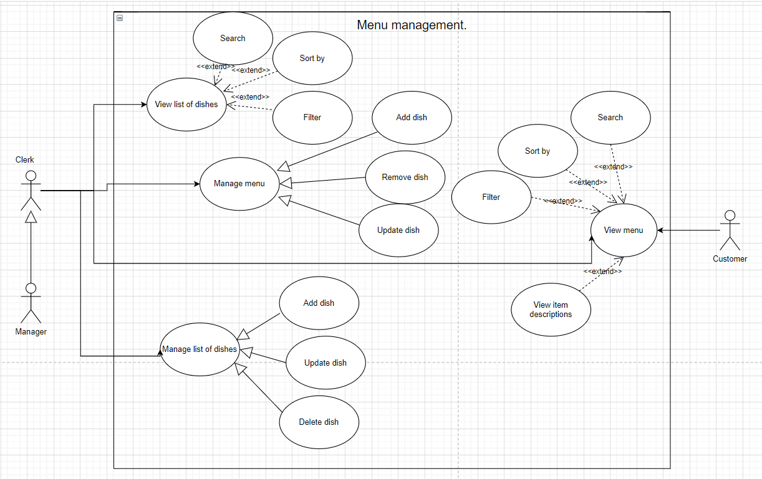

Use-case description table format:

| Use-case name | Menu management. |
| --- | --- |
| Primary Actor | Restaurant manager, clerk. |
| Description | The restaurant manager and clerk update the “list of dishes” to the database, add a description, price, image.  “List of dishes” is where all dishes of restaurant are stored, menu dishes are added from the “list of dishes”. Remove, add, update dishes for menu and fixed dishes |
| Preconditions | The database must be connected and loaded |
| Normal Flow | 1. Authorized people add the image, price, description, etc to the list of dishes  Case 1:  2. They can view the list of dishes  Case 2:  3. They can update or delete dishes on fixed dishes.  Case 3:  4. They can add dishes and quantities of each dish to the restaurant’s menu every day.  5. They can remove or update dishes on the menu  6. If the quantity is 0, temporarily show out of the stock or they can increase the quantity |
| Exceptions | If authorized people haven’t added any dishes to the lis of dish (list of dishes has no items) then alert that “The list of dish has no items”. And authorized people can’t add item to the menu.  If authorized people haven’t added any dishes to the menu (menu has no items) then alert that “The menu has no items” |